All about me
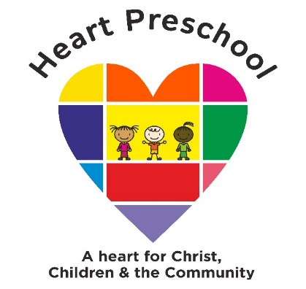
This is me…

This is my family…

I drew this picture when I started Heart Preschool

Left handRight hand
What I can do myself…
- Uses a variety of single words and speaks in sentences of 2 or more words
- Put on my coat & take off my coat
- Go to the toilet
- Wash my hands

- Use scissors
- Count to 5
- Count to 10
- Use a pencil and utensil
- Can jump with two feet
- Can walk up & down the stairs holding onto a rail
- Can climb onto furniture
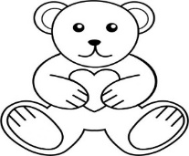
This Photo by Unknown Author is licensed under CC BY
Have you got any brothers or sisters?
My favourite toy is………………………………
My favourite story is ……………………..
My favourite song is…………………………….
I can name these colours……………………………………….
Have you got any pets?........................
Please feel free to add any additional information on the reverse, which you feel will help us to settle your child into our Preschool.

Signed…………………………………………………………………….…(parent/carer) date………………………………………..……

