Heart Preschool Newsletter
Welcome
A very warm welcome to all our new children and families who have joined us in the last few months. We’ve loved getting to know your children and see them settle in, build positive relationships with other children and with staff, and start to thrive in learning through their play at the setting.
As the new children to the setting have been forming these positive relationships with staff members, we have now selected who will be your child’s key worker and they will be introducing themselves to you via the Famly App in the next couple of weeks. We are also working on completing their 2 year old progress checks which we will contact you for feedback on shortly too.
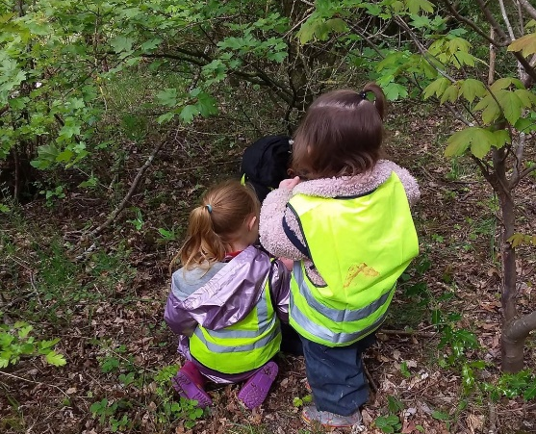
Below is a labelled picture of our staff team, so you can know who your little ones are talking about at home, and say hello when you see them at the door!
Left-right back row: Sarah, Becca, Lisa, Angela, Bekah, Dawn.
Left-right front row: Lucy, Naomi.

Updated Policies
We have recently updated our policy on attendance, arrivals and collections. This will be posted on the Famly App for your information, before the end of term.
Volunteers
We want to say another big thank you to our volunteers Kathryn & Ian; members of the church who come into preschool on a Tuesday morning to lead Bible Story activities and crafts with our Butterfly Room. The children so enjoy these special activities and have developed lovely connections with Ian & Kathryn during their time with us. They are invaluable to the setting! Please do say hello and thank them if you see them on a Tuesday.
We also want to say a big thank you to all the parent helpers who have given up their time on a Friday morning to support with our Forest Friday trips to the local woodland. We genuinely couldn’t do it without you, and the children who have attended these outings are absolutely thriving. It’s a joy to see them so involved and excited in exploring the natural world around them, so thank you VERY much to all those parents who are helping out.
Forest Friday Update from Angela
“Forest Friday has had a positive impact on the learning and development of all our children that attend a Friday session.
We have been implementing activities the children wouldn't necessarily get the opportunity to do like den building, tree climbing and exploring natural materials like clay and leaves.
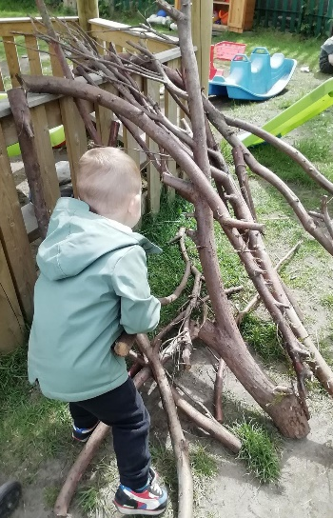
We have noticed the children really approaching the opportunities with curiosity, energy, and enthusiasm. These behaviours have really supported learning and have been meaningful to each child so that they are able to use what they have learned and apply it in new situations. In turn the children are making good progress in all the Areas of Learning and Development.”
Suncream Note
We have been made aware that Nivea Sun Kids Protect & Care sun cream now contains almond oil in its ingredients. As we are a nut free preschool, we have changed the type of sun cream we have available in the setting and ask that you please do not bring this sun cream in to the setting for your child.
We have created a new sun cream permission request on the Famly App. Please tick if you are happy for us to apply sun cream to your child during their time at preschool.
Upcoming Events
Jubilee Tea Party! You are invited to attend our Platinum Jubilee Afternoon Tea on Friday 27th May from 12-1pm. We’ll be setting up our Butterfly Room to treat our parents and children to an afternoon tea, served by our lovely staff team. Please let us know if you do or don’t plan on attending, and please note that parents present will be responsible for their children while our staff serve the goodies!
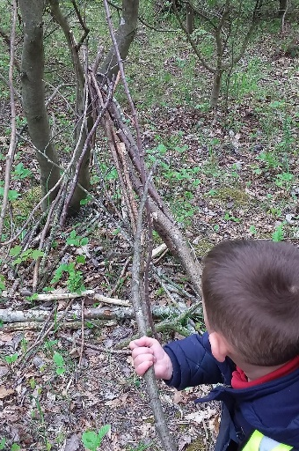
Summer Fayre! To celebrate over 4 years of Heart Preschool and to raise some funds to go towards new surfacing in the garden we will be holding a Summer Fayre from 2-4pm on Friday 17th June, and we would love for you to be there. There will be lots of stands, games and refreshments – it should be a fun event for all the family!
Dates for the diary
- Platinum Jubilee tea party: Friday 27th May, 12-1pm
- June half term: 30th May – 3rd June
- Summer Fayre: Friday 17th June, 2-4pm
- Sports Day: Tuesday 12th July (more information to follow)
- Last day of summer term: Friday 15th July

