Heart Preschool Newsletter
Introduction
A very warm welcome back to all the children who have started back after the summer holidays, and a big welcome to the new children starting for the first time this term. We are so excited to get to know you all!
We had loved seeing the change in all the children who attended last term and how confident they have become and watching some lovely friendships forming. The new children have wowed us with their resilience and confidence, we are sure they will continue to flourish and shine even more! We can’t wait to tell you more about the progress of your children during our end of term parents’ evenings.
In the caterpillar room you may have noticed your children coming home singing lots of songs, we have loved shaking our pompoms to lots of music! Your children have also been getting very messy and creative with the paintings, gluing and playdough that’s been on offer so far.
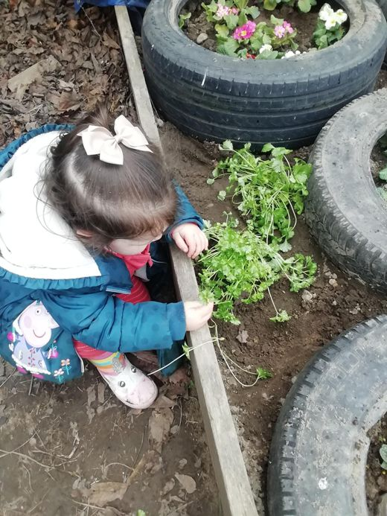
It is proven that children do some of the best learning when outdoors and is part of the EYFS curriculum! Therefore, as it approaches the wetter and colder seasons, we will continue to do our outdoor learning as much as possible. This will include your children jumping up and down in muddy puddles – which they love! It will be the children digging in the mud and making mud pies in our very popular mud kitchen. Therefore, it is important that the children are equipped for all types of weather – wellies, waterproof overalls, hats, and gloves which will really ensure that they can continue to enjoy the outdoors and get the most out of their learning journey at Heart Preschool.
Inset Day
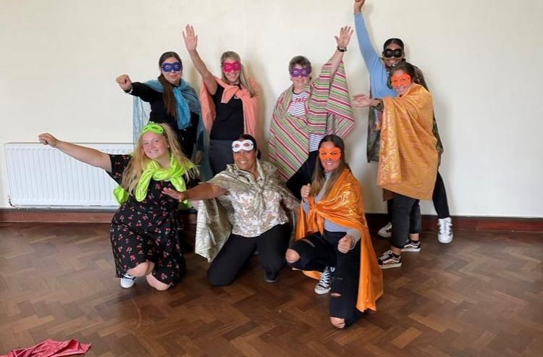

We are thankful that we get to have some inset days which allow us to get together as a team and prepare for the upcoming academic year. This year we had the privilege of having a guest appearance from Ben Kingston-Hughes who delivered a fantastic session all about the power of play! We discussed how having positive interactions with children can help them all the way through to adulthood. After that, we turned into superhero’s and unleashed our own individual imaginations.

Back to pre-school photos
What a lovely day we had with the children having their back to pre-school photo’s, all the children were fantastic! We will let you know when the pictures are back from the photographer. The following prices will be:
£10 for 2 prints 1xA4 and 1xA5
£10 for a digital copy of all photographs
Staff Updates
A very warm welcome to Kayleigh who has settled in nicely over the last few weeks.
Another welcome to Lisa who has taken on the role of acting Deputy.
Just a reminder…
A friendly reminder to please ensure your child’s name is clearly labelled on any items they bring to nursery. We do our best to remember what belongs to everyone, but it really does help us to have a name label!
Please also be reminded that we are a healthy food setting, so we do not allow fizzy drinks or sweets at the setting. Please be mindful of this when packing your child’s lunchboxes!
Please also be reminded to sign up to our Famly App where you will receive notifications on your child’s progress and to help you keep up to date with Preschool news.
Upcoming Events
It is important for us to be able to showcase your child’s development here at Heart preschool so keep a look out for when our parents evening slots become available.
After the successful stay and play sessions, we will be hosting another week of stay and plays for both butterflies and caterpillars after the October half term.
Dates for the diary
- Fitness day – 21st September
- European day of languages – 26th September
- Harvest festival donations – From the 30th September
- World animal day – 4th October
- Space week – 4th-10th October
- World smile day – 7th October
- Parents evenings – 12th & 13th October

