Heart Preschool Newsletter
Introduction
Welcome back everyone! We have missed you all and we hope you have enjoyed the two-week break. We are very excited to get back to playing and having lots of fun with your children this term.
We really enjoyed getting to know each child last term, we were amazed at the confidence and resilience they have shown. We are excited to continue to help develop your children further in the weeks ahead and are thankful for your continued support.
This term is one of our favourite terms, it’s a term where we can really come together as a setting with the children and you as parents and carers to celebrate different traditions and be thankful and supportive to our Heart preschool families and the community.
Throughout this term we have lots of fun and engaging things lined up. We will be continuing our Autumnal theme where we will be exploring the outdoor environment, including looking at different seasons. We will also be continuing to send out our home learning packs, which we know lots of children have LOVED!
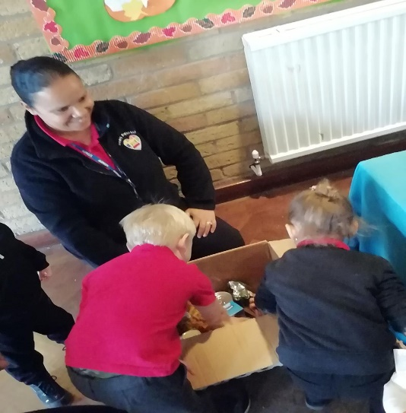

Exciting events
Remembrance Day
There will be an opportunity for you to be able to purchase a hand knitted poppy in support of Remembrance Day. A donation is encouraged but not essential. This will take place on Friday 11th November.
Nursery rhyme week is coming up and as a setting we are always singing with the children, this helps with their prime areas of development such as communication and language. We also have Rebecca Gordon coming to do a fantastic music and movement session with the children from Drama Safari.
Children in Need
Children in Need is on the 18th Of November, and we would love to fundraise some money towards this charity. We have decided to hold a cupcake competition running from the 14th – 18th of November. The winner will be announced on Friday the 18th. We will also be holding a cupcake sale from the 14th of November until Friday the 18th of November. Cakes will be sold from 50p and will be available to buy on drop-off and collection. Another event for this charity will be held on Friday the 18th of November, come dressed in Yellow or wearing your favourite Pudsey outfit for a 50p donation!
Toy Tabletop Sale to support Ukraine
Please come along to Heart preschool church on Saturday the 19^{th of} November. There will be a wide selection of new and good condition toys to buy. The prices are very good and would be a perfect Christmas present or gift for your children. At the same time, you will be supporting a fantastic charity close to our hearts. ALL proceeds go to the Ukrainian charity.
COME ON ENGLAND!
Help us cheer on England in the world cup by coming to preschool in your favourite England outfit or something red, white or blue on Monday 21st of November.
Alongside all the other exciting events, we have our most favourite celebration which is Christmas. This year we will be holding a wonderful Christmas Extravaganza where parents/carers will be invited into preschool to make some very special keepsake Christmas crafts with your children. This is such a good opportunity for you to be able to connect with your children and help spread the Christmas joy. We will also be joined by some of our previous Heart preschool children who we miss dearly! Not forgetting our very own Heart Preschool Christmas performance where we would love for you to help us get into the festive spirit by singing along with some Christmas carols and a chance for a photo opportunity of your children dressed in festive outfits. Finally, our end of term party day will be held on Wednesday the 21st of December, we will be accompanied by some year 3 and year 6 Glade Hill Primary School students. They will be helping with the smooth running of the party and to showcase how to be a ‘good role model’ to our Heart preschool children.
Staff Updates
A very warm welcome to Georgia who is joining us on a college placement from Basford Hall College. Georgia is keen to get some experience working with children as she develops on her Level 3 course.
Just a reminder…
As the cold weather approaches please continue to send appropriate clothing and footwear for your children including clearly labelled coats, hats, gloves, scarfs and wellies.
We break up for pre-school on Wednesday the 21st of December.
We return to pre-school on Thursday the 5^{th of} January.
Dates for the diary
- 11th Nov – Remembrance Day
- 14th November – Nursery Rhyme Week
- 14th November – Design your own cupcake week
- 14th November – Children in Need cake sale
- 16th November – Music and Movement session with Drama Safari (Rebecca Gordon)
- 18th November – Dress up for Children in Need Day
- 19th November – Ukrainian tabletop sale
- 21st November – World cup dress up day
- 14th December – Christmas Extravaganza Craft Day 2-4PM
- 19th December – Christmas Performance Day 1PM
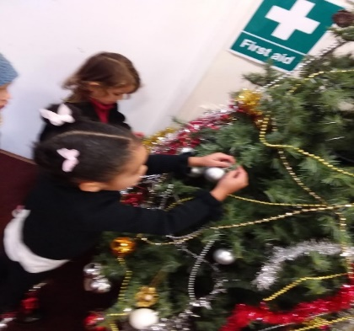
- 21st December – Christmas party day joined by year 3 and year 6 Glade hill students.

